Sanjeevan Engineering & Technology Institute, Panhala
Department of Electrical Engineering
Date: 21/07/2016
“Gurupornima Celebration”
REPORT
Event Date: 19/07/2016
The Department of Electrical Engineering celebrated the Gurupornima very gracefully. We have arranged an Essay Writing Competition on subject of “Relevance of Bhagwatgeeta on Modern Life” for S.E to B.E Electrical students. On this occasion students gave their best wishes to all teachers, Also Dept. has arranged a prize distribution ceremony for aggregate toppers of respective year. On this occasion we introduced our all new EEFA committee & respective members of committee.

Faculty Coordinator: Prof. Dipak. R. Shelar
Prof. Pallavi. G. Bendre
Head of the department: Prof.Prasad P. Kulkarni
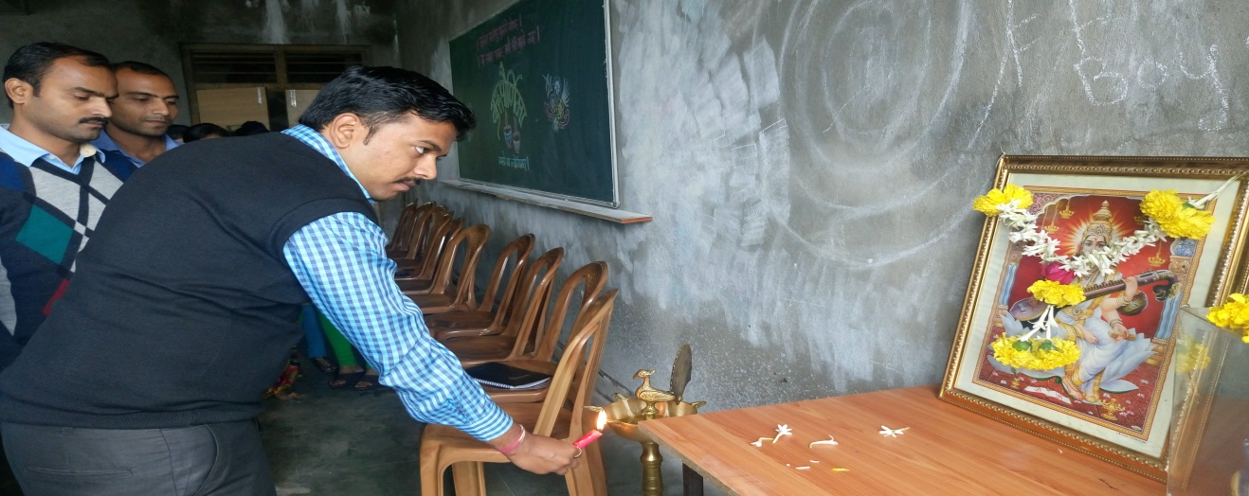

Inauguration

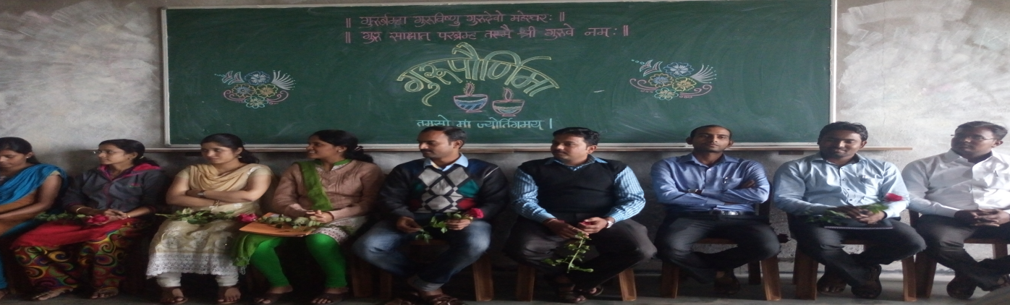

Staff Members

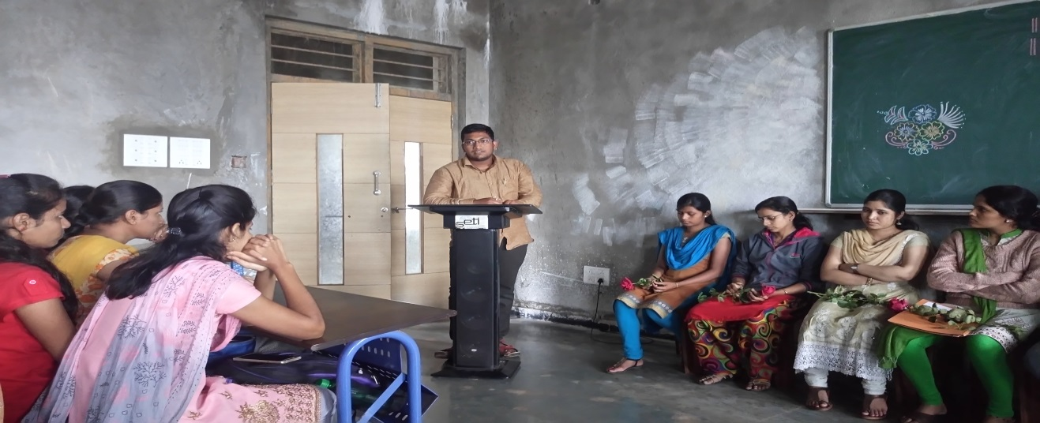
Speech by Students
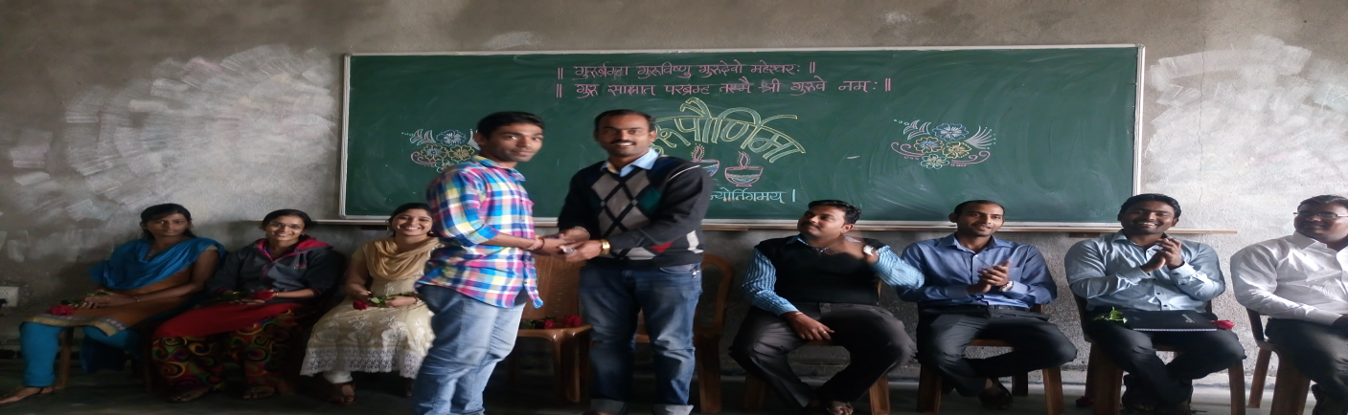

Prize Distribution

